RSL EDP PL/SQL
CODING STANDARDS

Table of Contents
Purpose 3
Scope 3
General Guidelines 3
Naming Conventions 4
Indentation & Formatting 8
Commenting Standards 9
Performance Best Practices 10
Exception Handling 10
Testing & Validation 11
Demo Package 12
References………………………………………………………………………………………………………………………12

RSL EDP PL/SQL Coding Standards

Change and Version Control Record
Version | Author | Date | Change Description
0.1 | Aswathi R | 07/10/2025 | Initial Creation
0.2 | Aswathi R | 07/21/2025 | Updated the changes received from SME

1. Purpose
To define standardized PL/SQL coding practices that improve readability, maintainability, and performance across procedures, functions, packages, and triggers in Oracle databases.
2. Scope
These guidelines apply to all developers writing PL/SQL code for Oracle-based applications or data workflows in EDP.
3. General Guidelines
- Break complex logic into modular subprograms.
- Use consistent naming for clarity and traceability (refer section 4 for naming conventions).
- Always includes robust exception handling.
- Comment thoughtfully — clarify intent, not just the syntax.
- Avoid using SELECT *; always specify only the required columns in your queries
- Use constants or configuration tables instead of hardcoding values directly in packages or procedures.
- Use global constants and global variables to promote consistency, reduce redundancy and simplify maintenance across the codebase.
- Use %TYPE to declare a variable with the same data type as a column in a table. This will reduce manual errors in data type declarations.
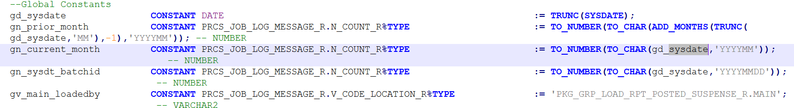

4. Naming Conventions
- Dependencies and used DB objects: Remove any listed dependencies or used objects from code comments, as they tend to become outdated and are not reliably maintained

Before:
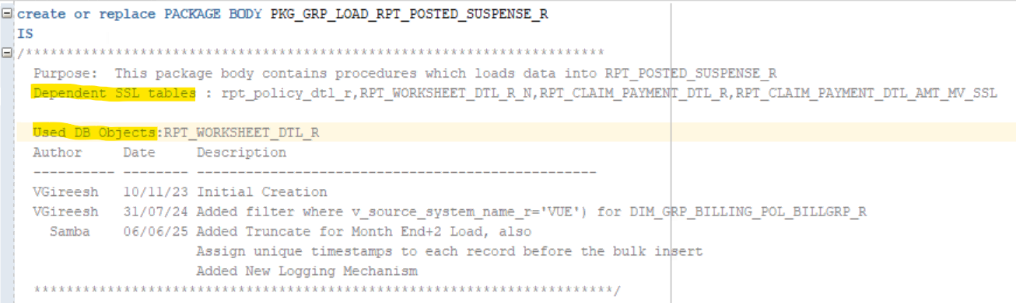

After:
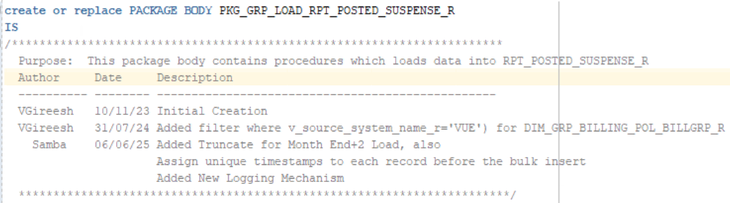

- Global and Local Variables: Variable Usage & Naming Standards
Global Variables
- Use for values shared across multiple procedures/functions within a package.
- Prefix with g to indicate global scope.
- Use clear type indicators, for example:
  - gv_ for VARCHAR2
  - gn_ for NUMBER
Local Variables
- Use for values used only within a single procedure or function.
- Prefix with l to indicate local scope.
- Maintain type indicators like global variables, for example:
  - lv_ for VARCHAR2
  - ln_ for NUMBER
  - lt_ for TIMESTAMP
Naming Convention
- Use a consistent prefix format: [scope][type]_[name]
- Scope prefixes:
  - g = global
  - l = local
- Type prefixes:
  - v = varchar/char
  - n = number/integer
  - t = timestamp
Best Practices
- Avoid using global variables unless necessary for sharing across procedures.
- Keep variable names descriptive yet concise for better readability.

Example:
Desc | Datatype | Global Variable | Local Variable
System Date | DATE | gd_sysdate | ld_sysdate
Month | Number/integer | gn_month | ln_month
Job name | Varchar/char | gv_job_name | lv_job_name
Start time | Timestamp | gt_start_time | lt_start_time

- Using %TYPE for Variable declaration
- %TYPE is used to declare a variable with the same data type as a column in a table.
- This ensures the variable always matches the column's type, even if the table changes later.
Here, gn_loop_counter_r will have the same data type as the N_COUNT_R column in the PRCS_JOB_LOG_MESSAGE_R table.

- Do not use "_r" suffix for variables defined in Packages and must be simple, clean, and meaningful to ensure clarity and ease of understanding
Example:

- CONSTANT keyword
Define constants using the CONSTANT keyword if values do not change.
Example:
- Integer datatype usage
All count-related fields that store integer values should use this data type

- Better commenting explaining when each function / procedure has been called.
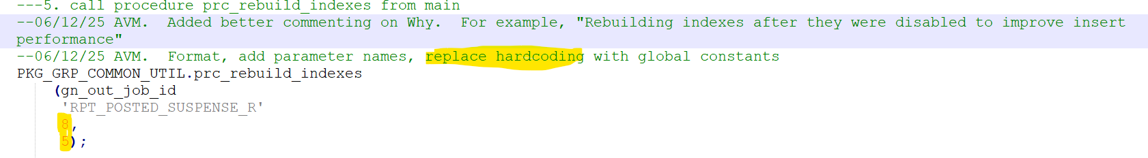

- Remove duplicate messaging
Avoid consecutive logging statements: Do not use multiple logging or print statements one after the other.
e.g., print(a), print(b), print(c)). Instead, combine them into a single statement to improve readability and performance (e.g., print (a, b, c) or use formatted strings

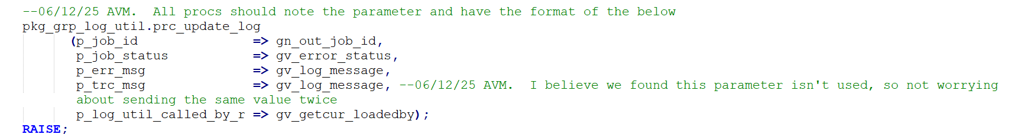

- Make sure standard coding practices followed

Use aliases for column and table names: Always use the AS keyword when assigning aliases to column names and table names to maintain clarity and consistency. Also, shorten the table name when using aliases to make the query more readable and concise.

Element | Convention | Example
Procedure  Function | PRC_load_<layer>_<lob>_<job>_R  FNC_<lob>_<Name> | PRC_LOAD_STG_GRP_CLAIM_SUMMARY_COVRG_TIER_TBL_R  PRC_LOAD_STG_GRP_CLAIM_SUMMARY_PAYMENT_DETAILS_R  PRC_LOAD_STG_GRP_CLAIM_SUMMARY_RESERVE_AMTS_R  FNC_GRP_TIME_DURATION
Cursor | prefix with c_ or prefix with cur_ | c_objects
Constants | Uppercase/Lowercase | DEFAULT_TAX_RATE
Packages | PKG_<Source>_Load_<Target>_<job>_R | PKG_GRP_LOAD_FCT_INCURRED_SUMMARY_R  PKG_GRP_LOAD_FCT_INCURRED_SUMMARY_R  PKG_GRP_LOAD_FCT_RPT_CLAIM_SUMMARY_R  PKG_GRP_LOAD_FCT_RPT_CROSS_SELL_SUMMARY_R
Triggers | trg_<table name>_<event> | trg_employee_before_ins
Indexes | <table>_IDX(1,2,3……) | TOTAL_EARN_PREM_LATEST7_INDX1  VW_FCT_CLAIM_PAYMENT_DETAIL_R_MV_SSL_IDX1  DIM_DATA_ORIGIN_HIST_IDX1
Sequences | seq_<table>_R | seq_employee_id_R
Views | V_<table name>_VW | V_active_employees_VW
Materialized Views | V_<table name>_MV | V_monthly_sales_MV
Synonyms | syn_<object> | syn_emp_table
Tables | FCT/DIM/STG/TEMP/TMP_<table name>_R | FCT_BENEFIT_PAYMENT_DETAIL_R  DIM_AGENT_PAYMENT_R  STG_ACT_ALL_LOB_DATA_R  TEMP_ANN_PREM_TABLE_FINAL_AGG_PRE  TMP_FCT_LG_RESERVE_DETAILS_R
Record Types | r_<table name> | r_emp_record
Collections (Tables of Records) | t_< table name > | t_emp_list
Exceptions | ex_< table name > | ex_invalid_salary
Loop Counters | Single-letter or short name | i, j, ctr

5.Indentation & Formatting
- Use 2 spaces per indentation level.
- Keep lines ≤100 characters wide.
- Add blank lines between logical code blocks.
- Include BEGIN...END even for simple code units.

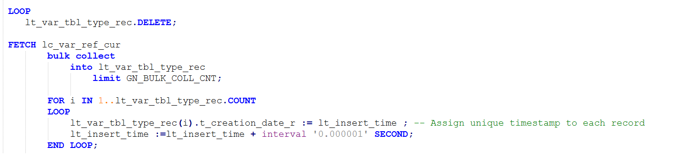

6. Commenting Standards
- Start each procedure, function, or block with a purpose comment.
- Use inline comments (--) sparingly and only when truly clarifying.
- Block comments (/*...*/) should annotate non-trivial logic.
- For any enhancement in the code, you should include a block comment with the details of the change.
- Avoid unnecessary or redundant comments
- If someone modifies the code, they must add a comment at the beginning of the modified section, including the date of the change and the name of the person making the modification.

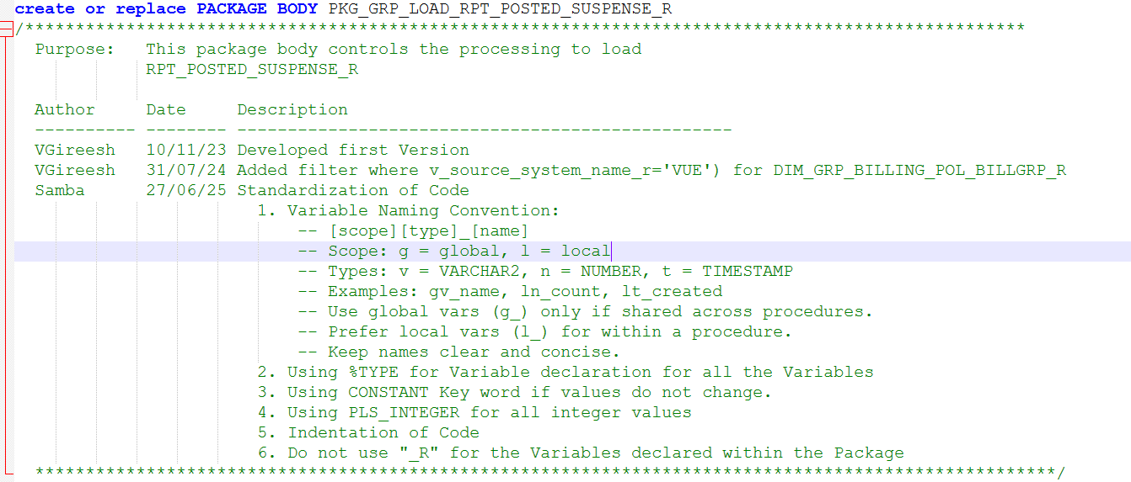

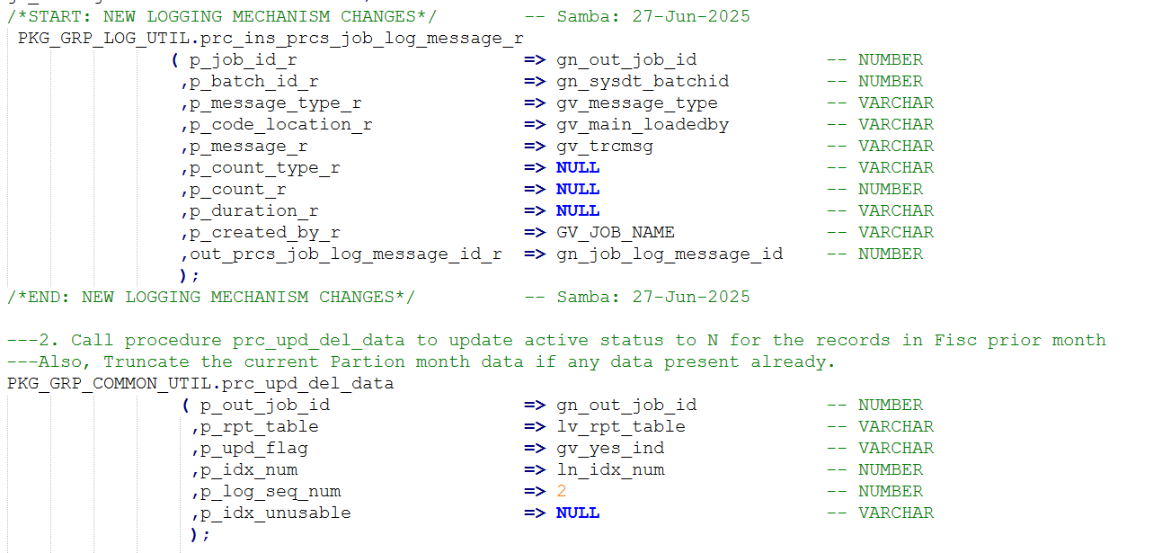
7. Performance Best Practices
- Use FORALL and BULK COLLECT for large dataset only when update and delete operations are performed
- For larger datasets use direct-path insert
- Index tables involve frequent joins or filters.
- Avoid unnecessary column selection; never use SELECT * in production code.
- Use appropriate and minimal data types to reduce memory and I/O overhead.
- Avoid implicit data type conversions in comparisons and joins.
E.g.: Use simple comparisons like tableA.column1 = tableB.column1 so the database can use indexes and run the query faster.
Avoid using functions on indexed columns in conditions, as this can make the index ineffective and slow down the query.
Eg:
tableA.column1 = tableB.column1 — Indexes will be used effectively
tableA.column1 = SUBSTR(tableB.column1, 2, 1) — Using a function like SUBSTR on tableB.column1 makes the index ineffective
- Partition large tables to improve query performance and manageability.
- Avoid unnecessary commits inside loops to reduce redo and undo overhead.
- Avoid excessive logging or debug output in production PL/SQL code.
- Include code modularization and avoid repetitive logic by rebuilding reusable procedures, functions, or packages wherever applicable.
- Remove commented -out code from the programme if it is not required.
- Optimize SQL Queries by first evaluating performance with INNER JOIN, then LEFT and RIGHT JOIN as needed; use EXPLAIN PLAN to analyse execution. Create necessary indexes before enabling parallelism, and ensure parallel execution is used only after discussion with the team to avoid unnecessary resources usage.
8. Exception Handling
- It is mandatory to handle all exception types first (e.g., NO_DATA_FOUND, TOO_MANY_ROWS) before using WHEN OTHERS as a fallback.
- Log exceptions using a reusable procedure or logging table.
- Always log exceptions using a centralized logging procedure or a dedicated
logging table. Include meaningful error messages with context (e.g., procedure name, parameters) in logs.
- For any new development or code changes, check with the lead if a logging mechanism already exists. Do not create new procedures or logging systems without confirmation.
- Use RAISE_APPLICATION_ERROR to return custom error messages to the calling environment from all child procedures.
- Use SQLCODE and SQLERRM to capture and log error codes and messages. Avoid using WHEN OTHERS THEN NULL; it hides errors and makes debugging difficult.
- All procs should note the parameter and have the format of the below

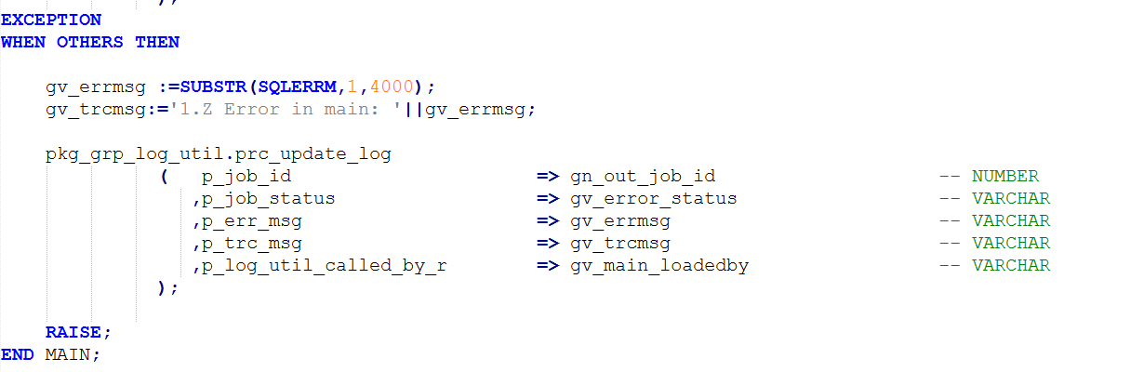

9. Testing & Validation
- Validate input parameters and expected output.
- Use realistic mock data for unit testing.
- Document boundary and edge cases in test coverage.
- Include a logging mechanism to capture execution details and errors during test runs for effective troubleshooting.
- For RPT tables add log in SSL_PACKAGE_LOG_TABLE/ RSLI_LOG/
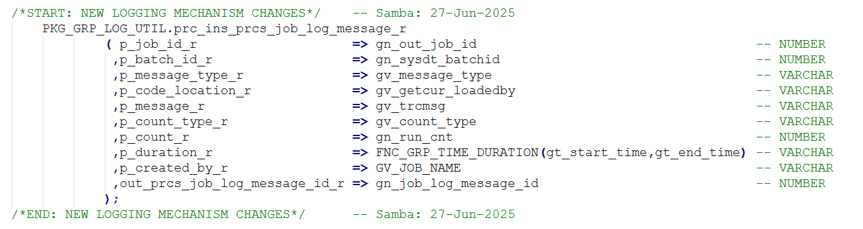

10. Version control
- Backups are utilized to safeguard data integrity and ensure business continuity by enabling quick recovery in case of data loss or corruption
- The version control setup and practices are currently a work in progress and will be updated as they evolve.
11. Demo Package

13.Reference
Database PL/SQL Language Reference
User's Guide

